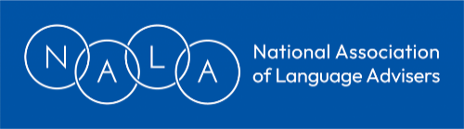
NALA Conference 2026 Booking Form
Date: Saturday, February 28th, 2026
Venue: University of Nottingham

Delegate Information
Name:
Job title (if appropriate):
LA/Company/Organisation:
Address:
Email:

Special requirements
Diet:
Access:

Booking options
NALA members (early bird: book by Monday 26 January 2026) £100
After Monday 26 January 2026 £110

Non-members
£120

- The closing date for applications is February 20, 2026.
- Prior to this date, cancellations will be accepted and refunds made (less a £20 admin charge), provided that these details are confirmed in writing to the Treasurer.
- After this date, no refunds will be paid for cancellations, unless a replacement delegate is found by the person cancelling.
- Conference places are not guaranteed until payment is received.
- The conference application will be acknowledged by the Treasurer.

Who is paying your conference fee? (Please tick)
I am paying my own conference fee.
My conference fee is being paid by someone else.
If your conference fee is being paid by someone else, please provide full details.
Name of organisation:
Contact:
Address:
Email:
Phone number:
Purchase order no (if relevant):

How to pay

Please use the following reference for all conference payments and correspondence
NALAConf/2026/YOURNAME

By cheque Please make cheque payable to National Association of Language Advisers

BY BACS transfer A/C Name: National Association of Language Advisers
Bank: NATWEST
Sort code: 01-01-42
A/C number: 36920509

Where to send your application:

By post Alison Taylor (NALA Treasurer)
15 Glenside Close
Bristol
BS16 2QY

By email alison.l.taylor@blueyonder.co.uk

Accommodation
For delegates requiring accommodation the night before, this is up to you to arrange. However, if you wish to use the onsite university conference accommodation, please email the treasurer above and a link can be sent.

