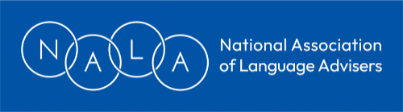
NALA Conference 2024 Application
Date: Saturday, June 29th, 2024
Venue: University of Nottingham, Faculty of Humanities

Delegate Information
Name:
Job title (if appropriate):
LA/Company/Organisation:
Address:
Email:

Special requirements
Diet:
Access:

Booking options
NALA members (early bird: book by Friday, April 12) £85
(After April 13) £95

Non-members (early bird: book by Friday, April 12) £95
(After April 13) £105

- The closing date for applications is June 14, 2024.
- Prior to this date, cancellations will be accepted and refunds made (less a £20 admin charge), provided that these details are confirmed in writing to the Treasurer.
- After this date, no refunds will be paid for cancellations, unless a replacement delegate is found by the person cancelling.
- Conference places are not guaranteed until payment is received.
- The conference application will be acknowledged by the Treasurer. However, this can only be sent after March 27th, due to absence.

Who is paying your conference fee? (Please tick)
I am paying my own conference fee.
My conference fee is being paid by someone else.
If your conference fee is being paid by someone else, please provide full details.
Name of organisation:
Contact:
Address:
Email:
Phone number:
Purchase order no:

How to pay

Please use the following reference for all conference payments and correspondence
NALAConf/2024/YOURNAME

By cheque Please make cheque payable to National Association of Language Advisers

BY BACS transfer A/C Name: National Association of Language Advisers
Bank: NATWEST
Sort code: 01-01-42
A/C number: 36920509

Where to send your application:

By post Alison Taylor (NALA Treasurer)
15 Glenside Close
Bristol
BS16 2QY

By email alison.l.taylor@blueyonder.co.uk

Please note, your application may not be acknowledged until after March 28th.
If you require an earlier acknowledgement, please submit your application via Bev Whiteside (bevwhiteside@outlook.com) instead.

